EXERCISE NO 3

Date: WRITING BASIC SQL SELECT STATEMENTS

Create table statement:

**CREATE TABLE departments (department_id NUMBER(6) NOT NULL,department_name VARCHAR2(25),manager_id NUMBER(6),location_id NUMBER(4));**

**CREATE TABLE employees(employee_id NUMBER(6) NOT NULL,first_name VARCHAR2(20),last_name VARCHAR2(25) NOT NULL,email VARCHAR2(25) NOT NULL,phone_number VARCHAR2(20),hire_date DATE NOT NULL,job_id VARCHAR2(10) NOT NULL,salary NUMBER(8, 2),commission_pct NUMBER(2, 2),manager_id NUMBER(6),department_id NUMBER(4));**

Insert table values:

**BEGIN**

**EXECUTE IMMEDIATE 'INSERT INTO departments (department_id, department_name, manager_id, location_id) VALUES (10, ''HR'', 101, 1400)';**

**EXECUTE IMMEDIATE 'INSERT INTO departments (department_id, department_name, manager_id, location_id) VALUES (20, ''Finance'', 102, 1700)';**

**EXECUTE IMMEDIATE 'INSERT INTO departments (department_id, department_name, manager_id, location_id) VALUES (30, ''IT'', 103, 1800)';**

**END;**

**/**

**BEGIN**

**INSERT INTO employees (employee_id, first_name, last_name, email, phone_number, hire_date, job_id, salary, department_id, manager_id) VALUES (100, 'John', 'Doe', 'jdoe@example.com', '1234567890', TO_DATE('12-JAN-2020', 'DD-MON-YYYY'), 'IT_PROG', 6000, 60, NULL);**

**INSERT INTO employees (employee_id, first_name, last_name, email, phone_number, hire_date, job_id, salary, department_id, manager_id) VALUES (101, 'Jane', 'Smith', 'jsmith@example.com', '0987654321', TO_DATE('15-FEB-2020', 'DD-MON-YYYY'), 'HR_REP', 4500, 70, 100);**

**INSERT INTO employees (employee_id, first_name, last_name, email, phone_number, hire_date, job_id, salary, department_id, manager_id) VALUES (102, 'Alice', 'Johnson', 'ajohnson@example.com', '5551234567', TO_DATE('01-MAR-2021', 'DD-MON-YYYY'), 'SALES', 4200, 70, 100);**

**INSERT INTO employees (employee_id, first_name, last_name, email, phone_number, hire_date, job_id, salary, department_id, manager_id) VALUES (103, 'David', 'Williams', 'dwilliams@example.com', '9876543210', TO_DATE('10-APR-2022', 'DD-MON-YYYY'), 'MARKETING', 7200, 80, NULL);**

**INSERT INTO employees (employee_id, first_name, last_name, email, phone_number, hire_date, job_id, salary, department_id, manager_id) VALUES (104, 'Emily', 'Brown', 'ebrown@example.com', '1112223333', TO_DATE('20-MAY-2023', 'DD-MON-YYYY'), 'FINANCE', 6800, 60, NULL);**

**INSERT INTO employees (employee_id, first_name, last_name, email, phone_number, hire_date, job_id, salary, department_id, manager_id) VALUES (105, 'Michael', 'Davis', 'mdavis@example.com', '4445556666', TO_DATE('05-JUN-2024', 'DD-MON-YYYY'), 'IT_PROG', 7500, 60, NULL);**

**INSERT INTO employees (employee_id, first_name, last_name, email, phone_number, hire_date, job_id, salary, department_id, manager_id) VALUES (106, 'Olivia', 'Miller', 'omiller@example.com', '7778889999', TO_DATE('15-JUL-2024', 'DD-MON-YYYY'), 'HR_REP', 5200, 50, NULL);**

**INSERT INTO employees (employee_id, first_name, last_name, email, phone_number, hire_date, job_id, salary, department_id, manager_id) VALUES (107, 'Noah', 'Wilson', 'nwilson@example.com', '2223334444', TO_DATE('25-AUG-2024', 'DD-MON-YYYY'), 'SALES', 6200, 30, NULL);**

**INSERT INTO employees (employee_id, first_name, last_name, email, phone_number, hire_date, job_id, salary, department_id, manager_id) VALUES (108, 'Ava', 'Taylor', 'atailor@example.com', '5556667777', TO_DATE('05-SEP-2024', 'DD-MON-YYYY'), 'MARKETING', 7800, 40, NULL);**

**INSERT INTO employees (employee_id, first_name, last_name, email, phone_number, hire_date, job_id, salary, department_id, manager_id) VALUES (109, 'Liam', 'Thomas', 'lthomas@example.com', '8889990000', TO_DATE('15-OCT-2024', 'DD-MON-YYYY'), 'FINANCE', 7000, 20, NULL);**

**END;**

**/**

TABLE PREVIEW:

**SELECT * FROM DEPARTMENTS;**

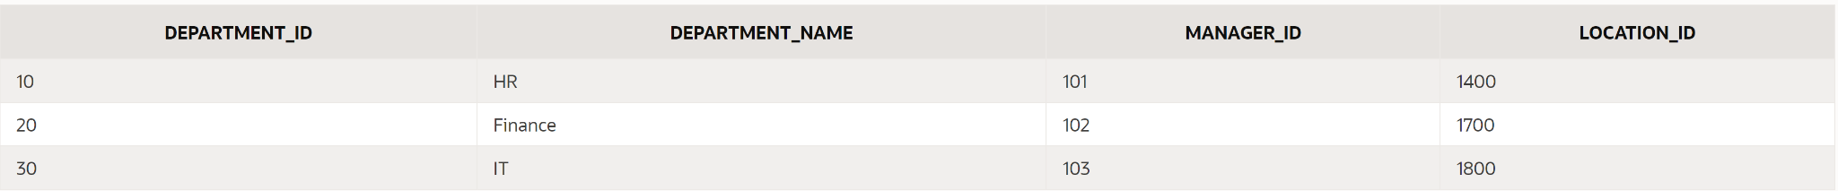

**SELECT * FROM EMPLOYEES;**

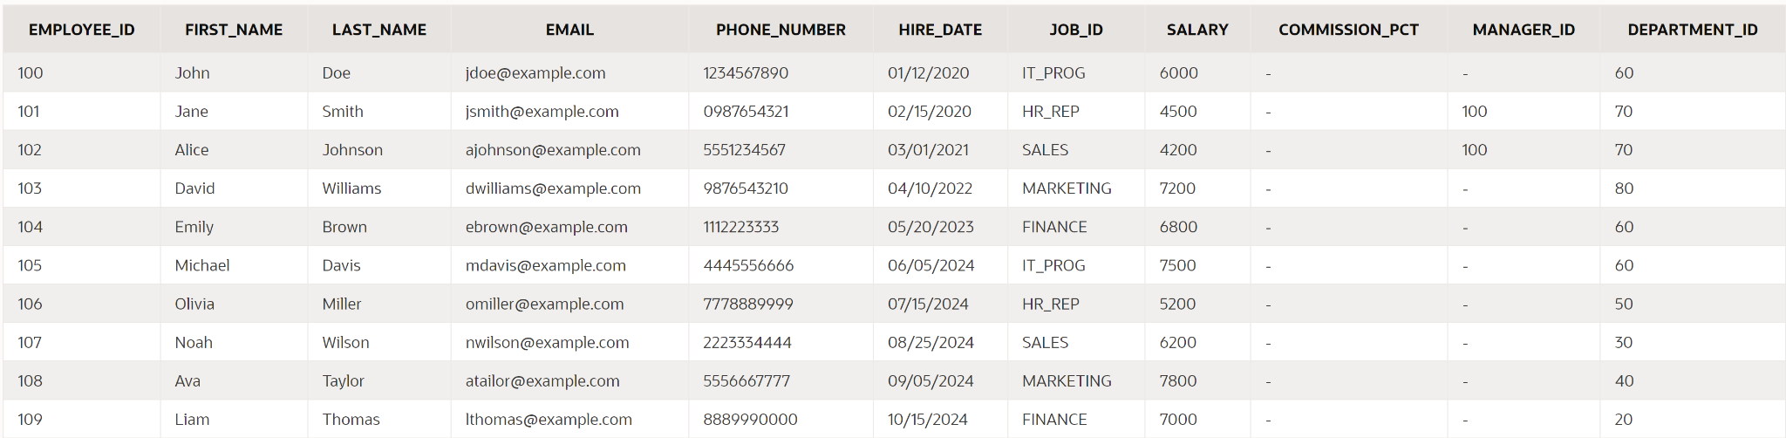

2. Show the structure of departments in the table. Select all the data from it.

PROGRAM:

**DESC DEPARTMENTS;**

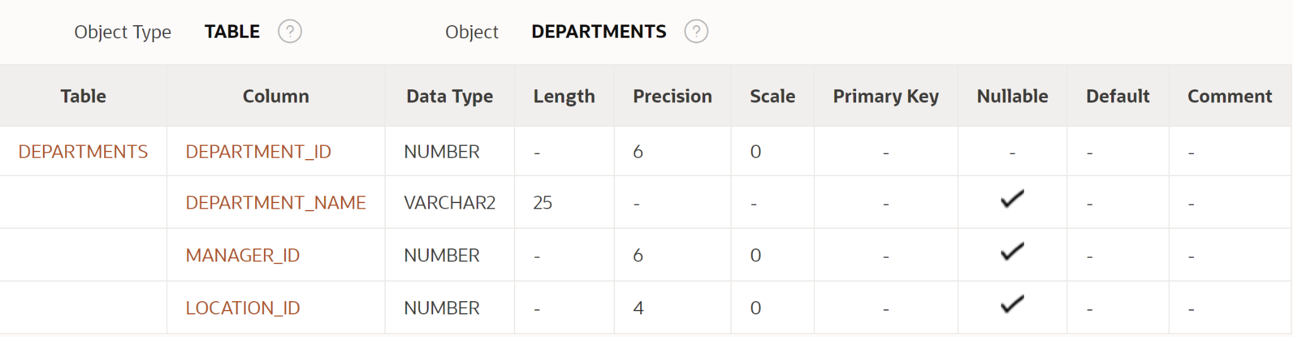

**SELECT * FROM DEPARTMENTS;**



3. Create a query to display the last name, job code, hire date, and employee number for each employee, with employee number appearing first.

PROGRAM:

**SELECT employee_id, last_name, job_id, hire_date FROM employees;**

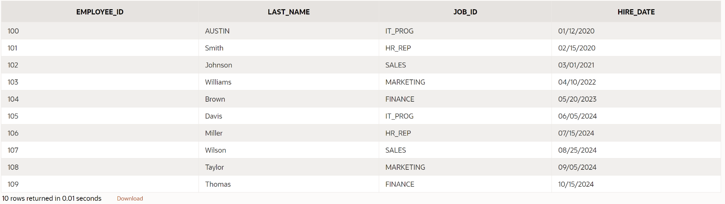

4. Provide an alias STARTDATE for the hire date.

PROGRAM:

**SELECT employee_id, last_name, job_id, hire_date AS STARTDATE FROM employees;**

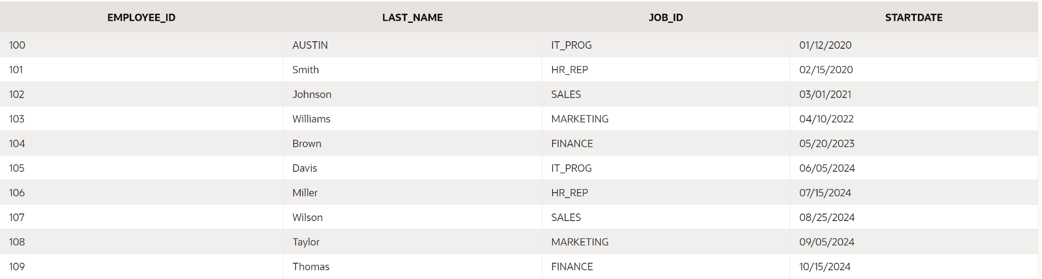

5. Create a query to display unique job codes from the employee table.

PROGRAM:

SELECT DISTINCT job_id FROM employees;

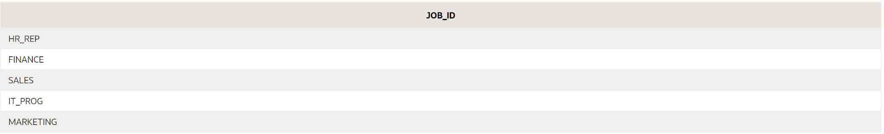

6. Display the last name concatenated with the job ID , separated by a comma and space, and name the column EMPLOYEE and TITLE. `

PROGRAM:

**SELECT last_name || ', ' || job_id AS "EMPLOYEE and TITLE"**

**FROM employees;**

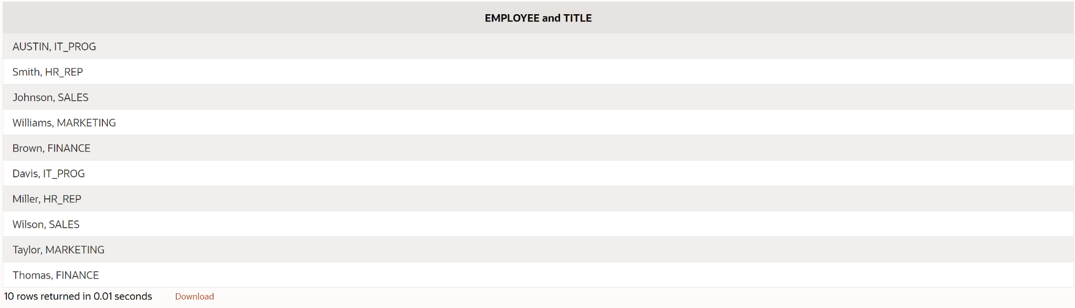

7. Create a query to display all the data from the employees table. Separate each column by a comma. Name the column THE_OUTPUT.

PROGRAM:

**SELECT employee_id || ', ' || first_name || ', ' || last_name || ', ' || job_id AS "THE_OUTPUT" FROM employees;**

